**SYNOPSIS**

**Report on**

**Smart Compost Monitoring System**

**by**

Ujjwal Aggarwal-2200290140167

Sparsh Goel - 2200290140154

**Session:2023-2024 (IV Semester)**

Under the supervision of

**Dr. Ankit Verma (Assistant Professor)**

### KIET Group of Institutions, Delhi-NCR, Ghaziabad

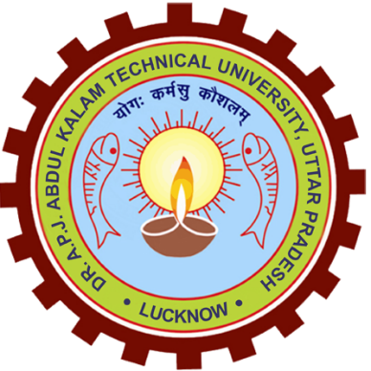

### Department Of Computer Applications

**KIET GROUP OF INSTITUTIONS, DELHI-NCR, GHAZIABAD-201206**

(2022 - 2024)

**ABSTRACT**

The Smart Compost Monitoring system helps to monitor and check the compost made by the amateur or low knowledgeable farmers and enthusiasts and an ideal ratio achievement is the subject of the current invention, The innovation is built on using several sensors to monitor and track record for the required amount of nutrition as well as the compulsory elements for acquiring an ideal compost the invention is not only limited to the Rural Areas it can be deployed to the Urban areas as well. The suggested technology will use a special machine learning algorithm to take the readings from the compost and compare it with the previously fetched ideal ratios and provide the difference that is to be then fulfilled by the farmer. Every crop with different requirements will have selected predefined ratios to be reached and monitored and different prerequisites will be achieved before fully deploying the system.

Furthermore, the paper can be a precise assessment of crucial parameters such as the carbon-to-nitrogen (C/N) ratio and pH levels, ensuring accuracy in composting endeavours. This innovation not only promises immediate assistance to those in need of natural compost but also eliminates the necessity for users to meticulously maintain nutritional levels during the composting process. By alerting users of any incompatible manure with their intended crops and confirming when optimal levels are achieved, the system offers comprehensive support throughout the composting journey. With its ability to autonomously analyse compost materials and provide

This research project focuses on the development and implementation of a Smart Compost Monitoring System tailored for rural and semi-urban communities, aiming to enhance composting practices and promote environmental sustainability. Through a comprehensive methodology involving literature review, stakeholder engagement, prototype development, field testing, and data analysis, the project aims to deliver a user-friendly and effective solution for optimizing compost quality and nutrient retention. The Smart Compost Monitoring System integrates advanced sensor technology and data analytics to provide real-time monitoring and intelligent feedback on key compost parameters, facilitating informed decision-making and resource optimization. By engaging stakeholders and fostering community participation, the project seeks to empower individuals with the knowledge and skills necessary to adopt sustainable waste management practices and drive positive environmental change. The project outcome is expected to contribute to improved soil health, reduced greenhouse gas emissions, and enhanced agricultural resilience in rural and semi-urban areas, while also promoting economic development and social well-being.

**Keywords:** Smart compost monitoring system; Internet of Things.

**TABLE OF CONTENTS**

Page Number

1. Introduction 4
2. Literature Review 5
3. Research Objective 6
4. Research Methodology 7-8
5. Research Outcome 9-10
6. Proposed Time Duration 11-13
7. References/Bibliography 14

**INTRODUCTION**

The Smart Compost Monitoring System. In a world increasingly focused on sustainable practices, composting stands out as a vital solution for managing organic waste while enriching soil health. Our innovative system revolutionizes the composting process by providing real-time monitoring and intelligent feedback to users. By accurately assessing key parameters such as the carbon-to-nitrogen (C/N) ratio and pH levels, our system ensures optimal composting conditions for maximum efficiency and nutrient retention. Beyond mere monitoring, our system actively guides users through the composting journey, alerting them to any compatibility issues with their intended crops and confirming when desired nutrient levels are achieved. With its user-friendly interface and autonomous capabilities, our Smart Compost Monitoring System empowers individuals and communities to effortlessly produce high-quality compost, promoting environmental sustainability and agricultural resilience. Join us in transforming waste into valuable resources with our pioneering composting solution.

Our Smart Compost Monitoring System represents a significant leap forward in composting technology, addressing the growing need for efficient waste management solutions. With traditional composting methods often relying on manual intervention and guesswork, our system offers a streamlined approach that takes the guesswork out of the equation. By leveraging advanced sensors and algorithms, we provide users with accurate and actionable insights into their compost piles, allowing for precise adjustments and optimization. Whether for individual households, community gardens, or large-scale agricultural operations, our system offers unparalleled convenience and effectiveness in compost management.

Furthermore, our project is not just about improving composting efficiency; it's about making a meaningful impact on both environmental and agricultural sustainability. By diverting organic waste from landfills and converting it into nutrient-rich compost, we contribute to reducing greenhouse gas emissions and mitigating soil degradation. Additionally, by enabling users to produce high-quality compost tailored to their specific needs, we support healthier plant growth and crop yields, fostering food security and resilience in a changing climate. With our Smart Compost Monitoring System, we envision a future where composting is not just a practice but a cornerstone of sustainable living and agricultural stewardship.

Moreover, our Smart Compost Monitoring System is designed with accessibility and inclusivity in mind, aiming to empower individuals of all backgrounds to participate in composting initiatives. Whether you're an experienced gardener or a novice enthusiast, our user-friendly interface and intuitive guidance make composting accessible to everyone. We prioritize simplicity and ease of use, ensuring that users can effortlessly navigate the system and understand the feedback provided. By breaking down barriers to entry and demystifying the composting process, we inspire broader adoption of sustainable practices and foster a sense of environmental stewardship among diverse communities. Together, we can harness the power of composting to create a healthier planet for future generations.

**LITREATURE REVIEW**

Moreover, the literature underscores the importance of raising awareness and educating users about the benefits of composting and the potential consequences of incorrect compost ratios, not only for crop growth but also for overall soil fertility. By fostering understanding among diverse communities, smart compost monitoring systems can empower individuals to make informed decisions about composting practices, thereby promoting broader adoption of sustainable waste management techniques. Additionally, future research directions should explore strategies for enhancing the accessibility and inclusivity of smart composting technologies, particularly in marginalized communities, to ensure equitable distribution of benefits and promote environmental stewardship on a global scale.

The literature surrounding composting practices has evolved significantly, particularly with the advent of smart compost monitoring systems, which have revolutionized traditional methods by integrating sensors and data analytics to provide real-time feedback on key parameters such as carbon-to-nitrogen ratio (C/N), pH levels, and temperature. These systems offer precise insights into composting conditions, enabling users to optimize compost quality and nutrient retention, thereby promoting environmental sustainability and agricultural resilience. However, challenges persist, including sensor accuracy, affordability, and scalability, especially in rural and semi-urban areas where composting is prevalent but resources and technical expertise are limited. Despite these challenges, the potential benefits of smart compost monitoring systems in diverting organic waste from landfills, reducing greenhouse gas emissions, and enhancing soil health and crop productivity underscore their importance in sustainable waste management and agricultural practices. Further research is needed to address existing limitations and maximize the socio-economic impact of smart composting technologies in diverse communities.

**PROJECT OBJECTIVE**

The objective of this project is to design and implement an accessible, user-friendly Smart Compost Monitoring System tailored for rural and semi-urban communities, with a focus on enhancing composting practices and promoting environmental sustainability. Leveraging advancements in sensor technology and data analytics, the system aims to provide real-time monitoring and intelligent feedback on key compost parameters, including carbon-to-nitrogen ratio (C/N), pH levels, and temperature. Through accurate assessment and guidance, the system will enable users to optimize compost quality and nutrient retention, thereby reducing greenhouse gas emissions, enhancing soil health, and improving crop productivity. Additionally, the project seeks to raise awareness and educate users about the benefits of composting and the potential consequences of incorrect compost ratios, fostering a sense of environmental stewardship and promoting broader adoption of sustainable waste management practices. Ultimately, the project aims to empower individuals in rural and semi-urban areas to participate in composting initiatives, contributing to a healthier planet and more resilient agricultural systems. Furthermore, the project aims to address the challenges of affordability and scalability commonly associated with smart compost monitoring systems, particularly in resource-constrained settings. By designing a cost-effective solution that utilizes readily available materials and prioritizes ease of installation and maintenance, the system will ensure accessibility for communities with limited financial resources. Moreover, the project will explore strategies for scalability, considering factors such as modular design and community-driven implementation models to facilitate widespread adoption and long-term sustainability. In addition to technological development, the project will focus on community engagement and capacity building to ensure the successful uptake and utilization of the Smart Compost Monitoring System. Through participatory workshops, training sessions, and educational outreach programs, community members will be empowered with the knowledge and skills necessary to effectively manage composting initiatives. By fostering a sense of ownership and collaboration, the project will create opportunities for knowledge exchange and peer-to-peer support, strengthening social networks and promoting collective action towards environmental sustainability. Ultimately, by combining technological innovation with community empowerment.

**PROJECT METHADOLOGY**

The research methodology encompasses a comprehensive approach starting with a thorough literature review to establish a foundational understanding of composting practices and existing smart compost monitoring systems. Following this, needs assessments and stakeholder consultations will be conducted to identify specific requirements and preferences of rural and semi-urban communities regarding composting. Subsequently, a prototype of the Smart Compost Monitoring System will be developed based on insights gathered, with iterative refinement through stakeholder feedback and usability testing. Field testing and evaluation will then be carried out in real-world composting environments, collecting data on system performance and user satisfaction. Data analysis will involve quantitative assessment of compost parameters and qualitative interpretation of stakeholder insights to evaluate system effectiveness and usability. Finally, research findings will be disseminated through various channels to contribute to knowledge sharing and facilitate broader adoption of the Smart Compost Monitoring System. Moreover, the research methodology prioritizes community engagement and participatory approaches to ensure the relevance and sustainability of the Smart Compost Monitoring System. Stakeholder consultations will involve community members, local authorities, and agricultural organizations, fostering collaboration and co-designing solutions that meet the unique needs of target communities. Throughout the research process, capacity-building workshops and knowledge-sharing sessions will be organized to empower community members with the skills and knowledge necessary to effectively utilize and maintain the system. By actively involving stakeholders in the research process, the methodology aims to foster ownership and long-term engagement, ultimately leading to the successful implementation and adoption of the Smart Compost Monitoring System in rural and semi-urban areas. Lastly, the research methodology emphasizes an interdisciplinary approach, drawing upon expertise from fields such as engineering, environmental science, agriculture, and social sciences. This interdisciplinary perspective will facilitate a holistic understanding of composting practices and enable the integration of technical innovations with socio-economic considerations. By bridging disciplinary boundaries and leveraging diverse perspectives, the research seeks to develop a Smart Compost Monitoring System that not only optimizes composting processes but also addresses broader socio-economic and environmental challenges facing rural and semi-urban communities. Through collaboration across disciplines, the research aims to generate innovative solutions that contribute to sustainable waste management and agricultural development.

**PROJECT OUTCOME**

The project aims to deliver a fully functional Smart Compost Monitoring System tailored for rural and semi-urban communities, empowering individuals to optimize composting practices and promote environmental sustainability. The outcome will consist of a robust hardware-software solution capable of real-time monitoring and intelligent feedback on key compost parameters, including carbon-to-nitrogen ratio (C/N), pH levels, and temperature. Through extensive stakeholder engagement and participatory design processes, the system will be tailored to meet the specific needs and preferences of target communities, ensuring usability, accessibility, and relevance. Field testing activities will provide valuable insights into system performance, user satisfaction, and impact on compost quality and agricultural outcomes, validating the effectiveness and scalability of the Smart Compost Monitoring System. Additionally, research findings and best practices will be disseminated through academic publications, conference presentations, and technical reports, contributing to the broader knowledge base on composting technology and sustainable waste management practices. Ultimately, the project outcome will empower individuals and communities to adopt more efficient and effective composting practices, leading to improved soil health, reduced greenhouse gas emissions, and enhanced agricultural resilience in rural and semi-urban areas.

Furthermore, the project outcome will extend beyond the technical aspects of compost monitoring, fostering a culture of environmental stewardship and community engagement. By raising awareness and providing education on the benefits of composting and sustainable waste management, the project will empower individuals with the knowledge and skills necessary to make informed decisions about their environmental impact. Through capacity-building workshops, knowledge-sharing sessions, and participatory activities, community members will be equipped to take ownership of composting initiatives, driving positive change at the grassroots level.

Moreover, the project outcome will serve as a catalyst for broader socio-economic development in rural and semi-urban areas. By promoting sustainable agricultural practices and improving soil fertility through composting, the project will contribute to increased crop yields, food security, and livelihood opportunities for local communities. Additionally, the adoption of the Smart Compost Monitoring System has the potential to generate economic value through the production and sale of high-quality compost products, creating new revenue streams for farmers and entrepreneurs. Ultimately, the project outcome will not only enhance environmental sustainability but also stimulate economic growth and social resilience in rural and semi-urban regions, laying the groundwork for long-term prosperity and well-being.

**PROPOSED TIME DURATION**

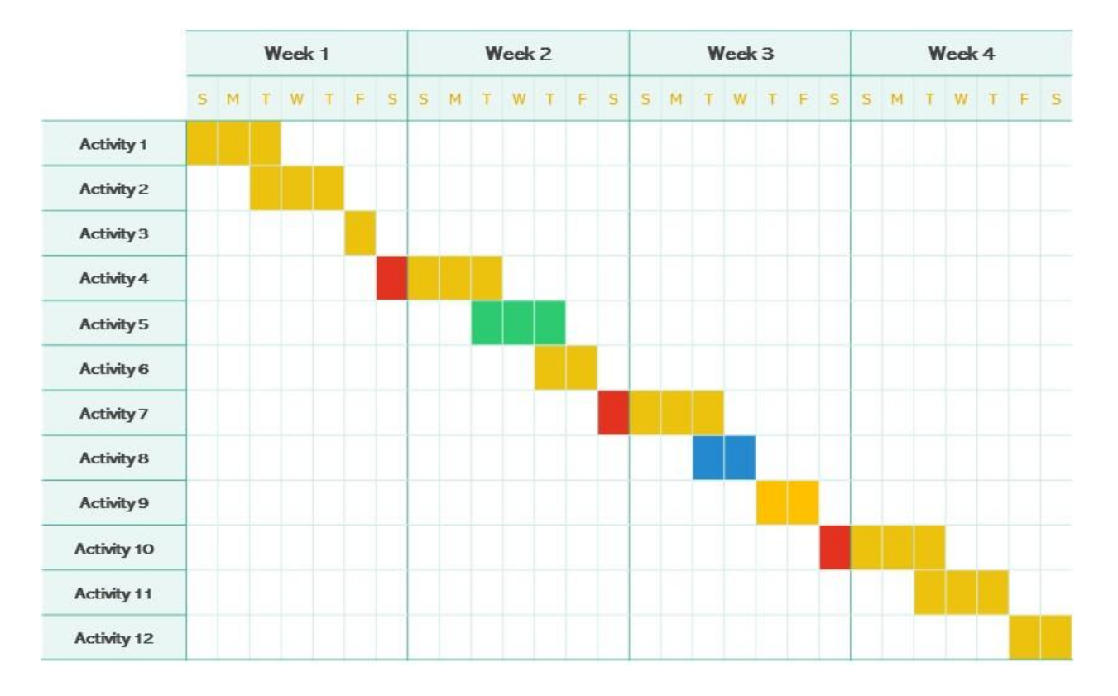

**Week 1:**

1. Conduct a thorough literature review on composting practices, smart compost monitoring systems, and sustainable waste management initiatives.

2. Initiate stakeholder consultations with rural and semi-urban communities, local authorities, and agricultural organizations to identify specific needs and preferences regarding composting.

3. Begin the design phase of the Smart Compost Monitoring System, outlining key features and functionalities based on insights gathered from the literature review and stakeholder consultations.

4. Develop a project timeline and allocate resources for the research project, including personnel, budget, and equipment requirements.

**Week 2:**

1. Continue stakeholder consultations to refine system requirements and gather feedback on the proposed design of the Smart Compost Monitoring System.

2. Start the prototype development process, focusing on hardware components (sensors) and software infrastructure (data collection, analysis, and user interface).

3. Establish partnerships with local organizations and community groups to facilitate access to composting sites and engage participants in field testing activities.

4. Conduct preliminary testing of sensor technologies and data collection methods to ensure compatibility and functionality.

**Week 3:**

1. Complete the development of the prototype Smart Compost Monitoring System, integrating hardware and software components.

2. Conduct usability testing and gather feedback from stakeholders to identify areas for improvement and refinement.

3. Prepare materials and resources for field testing activities, including data collection protocols, participant recruitment strategies, and safety guidelines.

4. Finalize plans for data analysis and interpretation, outlining key metrics and indicators for evaluating system performance and user satisfaction.

**Week 4:**

1. Deploy the Smart Compost Monitoring System in real-world composting environments, such as community gardens, small-scale farms, and household compost bins.

2. Monitor system performance and gather data on compost parameters, user interactions, and overall user experience.

3. Conduct ongoing data analysis to assess the effectiveness, usability, and scalability of the Smart Compost Monitoring System.

4. Begin drafting research findings and preparing materials for dissemination, including academic publications, conference presentations, and technical reports.

5. Conclude the four-week plan with a review meeting to discuss project outcomes, lessons learned, and next steps for further research and implementation.

**REFERENCE/BIBLOGRAPHY**

1:Riady Siswoyo Jo1, Marlene Lu2, Valliappan Raman3, Patrick HangHui Then4 "Design and Implementation of IoT-enabled Compost Monitoring System

2:Alessandra Cesaroa,∗ , Anna Contea , Vincenzo Belgiornoa , Antonietta Sicilianob , Marco Guidab "The evolution of compost stability and maturity during the full-scale treatment of the organic fraction of municipal solid waste.

3:Haris Isyanto*1, Jumail2, Rahayu1, Nofian Firmansyah1 "Design of Monitoring Device for the Process of Organic Waste Decomposition into Compost Fertilizer and Plant Growth through Smartphones based on Internet of Things Smart Farming.

4: Smart compost bin for domestic waste “1Swapna Raghunath, 2Charitha Madhagowni, 3Marla Laya Madhuri, 4Vemula Siva Shahitha, 5Dornala Ravishalini 1Professor in Electronics & Communication Engineering , 2Student, 3Student, 4Student, 5Student 1Electronics & Communication Engineering, 1G. Narayanamma Institute of Technology and Science (For Women),Shaikpet-Hyderabad, India.(2023).

 5:Comparative effectiveness of different composting methods on the stabilisation, maturation and sanitization of municipal organic solid wastes and dried faecal sludge mixtures. Tesfu Mengistu1*, Heluf Gebrekidan1 , Kibebew Kibret1 , Kebede Woldetsadik2 , Beneberu Shimelis1 and Hiranmai Yadav1.